

**INNOVATE. CREATE. SOLVE**

Bengaluru, Karnataka, India

AN

INTERNSHIP REPORT

ON

“TRIBUTE TO DOCTORS”

BACHELOR OF ENGINEERING

IN

ELECTRONICS AND COMMUNICATION

ENGINEERING

Submitted by :-VIJAY K(1AH18EC040)



ACS COLLEGE OF ENGINEERING

2021

## ABOUT THE COMPANY

IC Solution (ICS) is a digital service provider that aims to provide software, designing and marketing solutions to individuals and businesses. At ICS, we believe that service and quality is the key to success

We provide all kinds of technological and designing solutions from Billing Software to Web Designs or any custom demand that you may have. Experience the service like none other!

Some of our services include:

Development - We develop responsive, functional and super-fast websites.

We keep User Experience in mind while creating websites. A website should load quickly and should be accessible even on a small view-port and slow internet connection.

Mobile Application - We offer a wide range of professional Android, iOS & Hybrid app development services for our global clients, from a start up to a large enterprise.

Design - We offer professional Graphic design, Brochure design & Logo design. We are experts in crafting visual content to convey the right message to the customers.

Consultancy - We are here to provide you with expert advice on your design and development requirement.

Videos - We create a polished professional video that impresses your audience.

**TABLE OF CONTENTS**

Table of Contents

Overview of the Project 4

About Covid-19 5

Tribute To Doctors 6

Tools Used 7

Implementation(HTML) 8-15

Implementation (CSS) 16-23

Snapshots…………………………………………………………24-26

Bibliography………………………………………………………….27

About my team……………………………………………………….28

## OVERVIEW OF THE PROJECT

## Project Name: Tribute to Doctors

**Team Members:** VIJAY K

## This project is based on Web Development And its Applications. The main objective of this project is to learn the implementation of HTML, CSS and JavaScript. The basic webpage of this project is created using HTML and styling of the webpage is done using CSS.

## This webpage is a tribute to doctors who lost their lives in the covid19 second wave.

## I have done this project such a way that as if a newspaper website(Untitledcsv) is giving a tribute to the doctors.

## 

## ABOUT Covid-19

Coronavirus disease (COVID-19) is an infectious disease caused by a newly discovered coronavirus.

Most people infected with the COVID-19 virus will experience mild to moderate respiratory illness and recover without requiring special treatment.  Older people, and those with underlying medical problems like cardiovascular disease, diabetes, chronic respiratory disease, and cancer are more likely to develop serious illness.

The best way to prevent and slow down transmission is to be well informed about the COVID-19 virus, the disease it causes and how it spreads. Protect yourself and others from infection by washing your hands or using an alcohol based rub frequently and not touching your face.

The COVID-19 virus spreads primarily through droplets of saliva or discharge from the nose when an infected person coughs or sneezes, so it’s important that you also practice respiratory etiquette (for example, by coughing into a flexed elbow).

## Tribute To Doctors

Since the coronavirus outbreak, health-care professionals have not only experienced the gratification of healing patients and saving their lives but have also lost many battles along the way. On top of that, many doctors have even sacrificed their own lives in the line of duty. Every day, the selfless warriors are giving it their all in health-care settings while cutting themselves off from their families and loved ones. The sacrifice that they are making for the safety and welfare of humanity is priceless and deserves lifelong gratitude on our end.

"The nation is indebted to all the doctors, nurses and other health workers who have been front line warriors in this fight against the coronavirus."

We all learned many important lessons in the year 2020. An invisible virus has broken the myth that nature is subject to humans. I believe that the opportunity to adopt a lifestyle based on harmony with nature, by holding the right path, still exists in front of humanity. Like climate change, this epidemic has also raised the consciousness that the destiny of every member of the world community is interlinked. Most importantly, we must reassess the value health-care workers hold in our lives and the kind of treatment they get from us.

While the deadly virus has brought attention to the inadequacies in the health-care systems across the globe, doctors and health-care workers have been risking their lives to save all of us. They are also risking the lives of their family members, which indeed is a huge sacrifice. On top of that, the shortage of face masks, shields, and protective gear is not helping. And this makes the efforts of the medical workers even more extraordinary

## 



<!DOCTYPE html>

<html>

<head>

    <meta charset="utf-8">

    <title>Tribute To Doctors </title>

    <meta name="viewport" content="width=device-width, initial-scale=1, maximum-scale=1" />

    <link rel= "stylesheet" href="Untitled.css"/>

</head>

<body>

  <div class="container">

    <nav role="navigation" >

    <ul id="menu">

    <li><a href="https://www.cowin.gov.in/" target="_blank">Cowin</a></li>

    <li><a href="https://www.pmcares.gov.in/en/" target="_blank">Donate</a></li>

    <div id="abc">

    </div>

</ul>

    <div class="quote">

    <!--<span class="left">❝</span>-->

    <blockquote>

        <p>"SOME SUPERHEROES DON'T WEAR CAPES...

    </p>

    <P>THEY ARE CALLED DOCTORS..</P>

        </blockquote>

    <small class="name">-Anonymous</small>

    <!--<span class="right">❞</span>-->

</div>

</div>

<section class="main">

<div class="m-info">

    <h1>untitledcsv</h1>

    <h2>Special Edition</h2>

    <h5>Sept 30 2021,12:48 IST</h5>

    <h1>A Tribute To India's Covid Warriors.</h1>

<p>

    The Covid-19 pandemic is one of the most dangerous challenges this world has faced in our lifetime. It is above all a human crisis with severe health and socio-economic consequences. Needless to say, doctors, nurses and people working in health-care sectors are particularly vulnerable to the highly infectious disease.

     </p>

     <p>

        The list of the sleep-deprived heroes includes doctors, nurses, medical cleaners, pathologists, paramedics, ambulance drivers, and health-care administrators, the brave medical army and medical researchers working day in and night out against all odds.

</p>

<h2>A tribute to frontline corona warriors––Doctors who sacrificed their life while saving patients during the ongoing COVID-19 pandemic</h2>

<p>

    The 2019–2020 coronavirus pandemic is upending life on a global level as we know it. The highly infectious coronavirus disease 2019 (COVID-19) is caused by severe acute respiratory syndrome coronavirus 2 (SARS-CoV-2). It was first seen in Wuhan, Hubei, China where its outbreak was first identified in December 2019. After almost 3 months, on March 11, 2020, the World Health Organization recognized it as a pandemic considering its significant ongoing spread in multiple countries across the world.</p>

<p>

As of April 11, 2020, approximately 1,741,621 cases of COVID-19 have been confirmed in over 210 countries and territories resulting in around 106,670 deaths. Clearly, the corona virus outbreak situation cannot be taken lightly. Global pandemic of COVID 19, its ophthalmic implications, and precautions are nicely summarized in recently published editorial.</p>

<p>

While on one hand people across India and around the globe are largely confined to their homes with businesses and educational institutions all shut down in an attempt to contain the virus, and on the other hand doctors, health-care workers, and medical staff members are leading the battle against COVID-19 from the front. </p>

<p>

    putting their own lives at risk with selfless determination for the sake of saving lives, they truly are our heroes in these challenging times. While they are putting their own health, families, and most importantly their own lives at risk, the least we can do is appreciate their efforts and cooperate by staying safe indoors. That being said, it is good to see tributes pouring in for all the medical heroes working in scrubs.

<p>

    On occasion of the Doctors' Day <em>(March 30, 2020 USA and Australia)</em>, the stories of the medical heroes are inspiring and heartbreaking at the same time

</p>

<h3><marquee direction="right"> <fontcolor="white">"A Big Salute To Our Covid warrior"</fontcolor></marquee></h3>

<div>

    <img src="doctors.webp" width="800" height="1000">

</div>

</div>

<div class="video">

    <iframe width="400" height="200" src="https://www.youtube.com/embed/-rtuEgAHWw0">

    </iframe>

    <br>

    <br>

    <br>

    <br>

    <h3>District Wise death report of Karnataka</h3>

    <table id="stats">

        <tr>

          <th>name</th>

          <th>active</th>

          <th>recover</th>

          <th>Death</th>

          </tr>

          <tr>

          <td>Bagalkot</td>

          <td>121</td>

          <td>125</td>

          <td>25</td>

          </tr>

          <tr>

          <td>Raichur</td>

          <td>85</td>

          <td>25</td>

          <td>4</td>

        </tr>

        <tr>

          <td>Bangalore urban</td>

          <td>145</td>

          <td>55

          <td>66</td>

        </tr>

        <tr>

          <td>Bangalore rural</td>

          <td>124</td>

          <td>23</td>

          <td>35</td>

          </tr>

          <tr>

            <td>bijapur</td>

            <td>51</td>

            <td>22</td>

            <td>43</td>

            </tr>

          <tr>

          <td>Gulburga</td>

          <td>44</td>

          <td>33</td>

          <td>22</td>

        </tr>

        <tr>

          <td>Ramnagar</td>

          <td>40</td>

          <td>33</td>

          <td>31</td>

        </tr>

        <tr>

          <td>Gadag</td>

          <td>39</td>

          <td>55</td>

          <td>66</td>

          </tr>

          <tr>

          <td>Hassan</td>

          <td>39</td>

          <td>55</td>

          <td>33</td>

          </tr>

          <tr>

          <td>chitradurga</td>

          <td>37</td>

          <td>66</td>

          <td>22</td>

          </tr>

          <tr>

          <td>Mandya</td>

          <td>76</td>

          <td>33</td>

          <td>44</td>

          </tr>

          <tr>

            <td>Mysore</td>

            <td>244</td>

            <td>78 </td>

            <td>66</td>

            </tr>

          <tr>

          <td>Haveri</td>

          <td>23</td>

          <td>44</td>

          <td>46</td>

          </tr>

          <tr>

              <td>Udupi</td>

              <td>199</td>

              <td>44</td>

            <td>55</td>

          </tr>

          <tr>

          <td>Davengere</td>

          <td>166</td>

          <td>23</td>

          <td>55</td>

          </tr>

          <tr>

          <td>Kodagu</td>

          <td>100</td>

          <td>55</td>

          <td>77</td>

          </tr>

          <tr>

          <td>Bagalkot </td>

          <td>99</td>

          <td>22</td>

          <td>55</td>

          </tr>

          <tr>

            <td>Kalburgi</td>

            <td>188</td>

            <td>55</td>

            <td>7</td>

            </tr>

          <tr>

          <td>Haveri</td>

          <td>68</td>

          <td>55</td>

          <td>6</td>

          </tr>

          <tr>

          <td>Chikkabalapur</td>

          <td>54</td>

          <td>51</td>

          <td>3</td>

          </tr>

          <tr>

          <td>Yadagiri</td>

          <td>221</td>

          <td>55</td>

          <td>3</td>

          </tr>

          <tr>

          <td>Bidarr</td>

          <td>95</td>

          <td>7</td>

          <td>65</td>

          </tr>

          <tr>

          <td>Dakshina Kannada</td>

          <td>88</td>

          <td>55</td>

          <td>66</td>

          </tr>

          <tr>

          <td>Koppal</td>

          <td>78</td>

          <td>17</td>

          <td>55</td>

          </tr>

          <tr>

          <td>Tumkur</td>

          <td>2</td>

          <td>1</td>

          <td>0</td>

          </tr>

          <tr>

          <td>Vijaypura</td>

          <td>19</td>

          <td>3</td>

          <td>1</td>

        </tr>

      </table>

      <h4>Source:Government of Karnataka as on 30 sep 2021</h4>

      <br>

      <br>

      <br>

      <iframe width="400" height="200" src="https://www.youtube.com/embed/4ePre_8lxTw">

      </iframe>

      <br>

      <br>

      <br>

      <br>

      <iframe width="400" height="200" src= "https://www.youtube.com/embed/p37OxxEA8j8">

      </iframe>

</div>

</section>

<footer id="footer">

    <div class="f-info">

        Team untitledcsv

        <br>

        <a href="mailto:untitledcsv@gmail.com">untitledcsv@gmail.com " </a>

        <br>

        <div class="footer-sym">

            <a href="#"><img src="fb.png"></a>

            <a href="#"><img src="twitter.png"></a>

            <a href="#"><img src="insta.png"></a>

            <a href="#"><img src="git.png"></a>

        </div>

    </div>

    <div class="fr">

        <p id="cu">Contact Us</p>

        <p id="at">untitledcsv</p>

        <p id="ad">#412/412 2nd cross,jaynagar,Bangalore-82.</p>

        <div id="myform">

            <form>

                <div id="fg">

               </div>

               <div id="fg">

                   <label>Comments:</label>

                   <input type="textarea" name="Message">

               </div>

               <div id="submit">

                   <input type="Submit" value="submit">

                   </div>

            </form>

        </div>

    </div>

</footer>

</body>

</html>



title{

    font-family: Verdana, Geneva, Tahoma, sans-serif;

}

body{

    margin: 0;

    background-image: url("baground.jpg");

}

ul{ width:auto;

    height:50px;

    position:fixed;

    border:0;

    width:99%;

    padding:15px;

    margin-top:0;

    background: rgb(226, 221, 221);

}

li {

    list-style: none;

    margin:0;

    border:0;

    text-align: center;

    float:right;

}

.container {

  padding-bottom: 20px;

}

.main{

    width:auto;

    flex-shrink: 0;

    padding-top:10px;

    padding: 20px;

    padding-bottom: 0%;

    margin:5%;

    text-align: center;

    background-color: rgb(246, 248, 250);

    display:inline-flex;

    margin-bottom: 0px;

}

.m-info h1{

  font-size: 60px;

  text-align: left;

  margin-top:0px;

}

.m-info{

  flex:2;

  width:70%;

  order:1;

  text-align: left;

  font-family: 'Trebuchet MS', 'Lucida Sans Unicode', 'Lucida Grande', 'Lucida Sans', Arial, sans-serif;

  font-size: 20px;

  padding-top: 5px;

  padding: 30px;

  justify-content: space-evenly;

}

.video{

  flex:1;

  order:2;

  width:30%;

  margin-top: 22%;

}

#abc {

  float:left;

  position:fixed;

  list-style: none;

    font-family: Helvetica;

    font-style: normal;

    font-weight:bold ;

    color: white;

    background-color: black;

    margin-right: 6 px;

    border:0;

    text-align: center;

}

li a{

    display: block;

    font-weight: bold;

    font-family: verdana;

    font-size: 13px;

    color:rgb(245, 239, 239);

    justify-content: center;

    background-color: rgb(235, 60, 60);

    padding-top :13px;

    padding-bottom: 13px;

    padding-left:8px;

    padding-right:8px;

    margin-right:3px;

    margin-left: 3px;

    border:8px;

    border-radius:4px  ;

    text-align: center;

    text-decoration:none;

}

li a:hover{

    color:black;

    padding-top :15px;

    padding-bottom: 15px;

    padding-left:10px;

    padding-right:10px;

    margin-right:3px;

    margin-left: 3px;

    border:10px;

    border-radius:4px;

    background-color:#5dccbd;

}

.quote{

  float:left;

  text-align: center;

  font-size: 3.3rem;

  margin-top: 65px;

  height:30%;

  padding: 15px;

  padding-bottom: 10px;

  max-width: 70%;

  animation-name: jump;

  animation-duration:1s;

}

blockquote {

  padding: 0.5em 10px;

  padding-bottom: 0%;

  margin-bottom: 0%;

  quotes: "\201C""\201D""\2018""\2019";

}

blockquote:before {

  color: rgb(7, 7, 7);

  content: open-quote;

  font-size: 4em;

  font-style: italic;

  line-height: 0.1em;

  margin-right: 0.25em;

  vertical-align: -0.4em;

}

blockquote p {

  display: inline;

  font-style: italic;

  color:#f7f0f0;

}

/*blockquote{

  color: #e6a9d3;

  text-shadow: -1px 1px #555;

  font-style: italic;

  position: relative;

  z-index: 20;

}

.left{

  position: absolute;

  top: -30px;

  left: -5px;

  width: 150px;

  text-align: left;

  z-index: 10;

  font-size: 8rem;

  color: #336699;

  background-color: #ffcc00;

  line-height: 200px;

}

.right{

  position: absolute;

  bottom: 60px;

  right: -5px;

  width: 150px;

  text-align: right;

  z-index: 10;

  font-size: 8rem;

  color: #336699;

  background-color: #ffcc00;

  line-height: 200px;

}*/

small{

  font-size: 1.7rem;

  color: #336699;

  position: relative;

  z-index: 20;

}

 .quote .name{

      z-index: 15;

      right:-10px;

  }

  #stats {

    font-family: Arial, Helvetica, sans-serif;

    border-collapse: collapse;

  width:100%;

  margin-left:1%;

  }

  #stats td, #stats th {

    border: 1px solid rgb(15, 15, 15);

    padding: 8px;

  }

  #stats tr:nth-child(even){background-color: #d6d184;}

  #stats tr:hover {background-color: rgb(64, 187, 64);}

  #stats th {

    padding-top: 12px;

    padding-bottom: 12px;

    text-align: center;

    background-color: #e6f5e4cb;

    color: rgb(9, 10, 10);

  }

::-webkit-scrollbar

{

   width: 15px;

}

::-webkit-scrollbar-track

{

   border:7px ;

   background-color: rgb(187, 54, 54);

}

::-webkit-scrollbar-thumb{

    width:15px;

    background: linear-gradient(45deg,#0a8ee6,#a36634);

}

#footer {

  display: flex;

  background-color: rgb(31, 27, 27);

  height:260%;

  margin:0px;

  width:100%;

}

.f-info{

  flex:2;

  order:1;

  font-size:35px;

  margin-left:20px;

  text-align: left;

  text-decoration: none;

  color:rgb(253, 250, 250);

  padding:20px;

  padding-top:30px;

}

.f-info a{

  font-size:20px;

  color:inherit;

  text-decoration: none;

}

.footer-sym a{

    display: inline-block;

    width: 35px;

    height: 38px;

    cursor: pointer;

    background-color:  #33383b;

    border-radius: 2px;

  padding:1px;

  margin-top:15px;

    font-size: 20px;

    color: #ffffff;

    text-align: center;

    line-height: 35px;

    margin-right: 3px;

    margin-bottom: 5px;

}

.fr{

  flex:1;

  order:2;

  margin-left:20px;

  text-align: left;

  font-size: 20px;

  display:block;

}

#myform{

  margin-top: 40px;

  margin-left: 3%;

  color:#f8f5f5;

  font-family: Verdana, sans-serif;

  font-size: 15px;

  text-align: left;

  float: auto;

}

#myform label{

  display: block;

}

#myform input[type="textarea"]{

  padding:15px;

  width:50%;

  height:30%;

}

#submit{

  border-radius: 5px;;

}

#cu{

  font-size:25px;

  color:#faf6f6;

}

#at{

    font-size:13px;

    color:#fcf6f6;

}

#ad{

    font-size:13px;

    color:#faf5f5;

}

@keyframes jump

{

    0%

    {

        opacity: 0;

        transform: translateX(-200%);

    }

    100%

    {

        opacity:1;

        transform: translateX(0);

    }

}

**IMPLEMENTATION**

**Snapshots :**

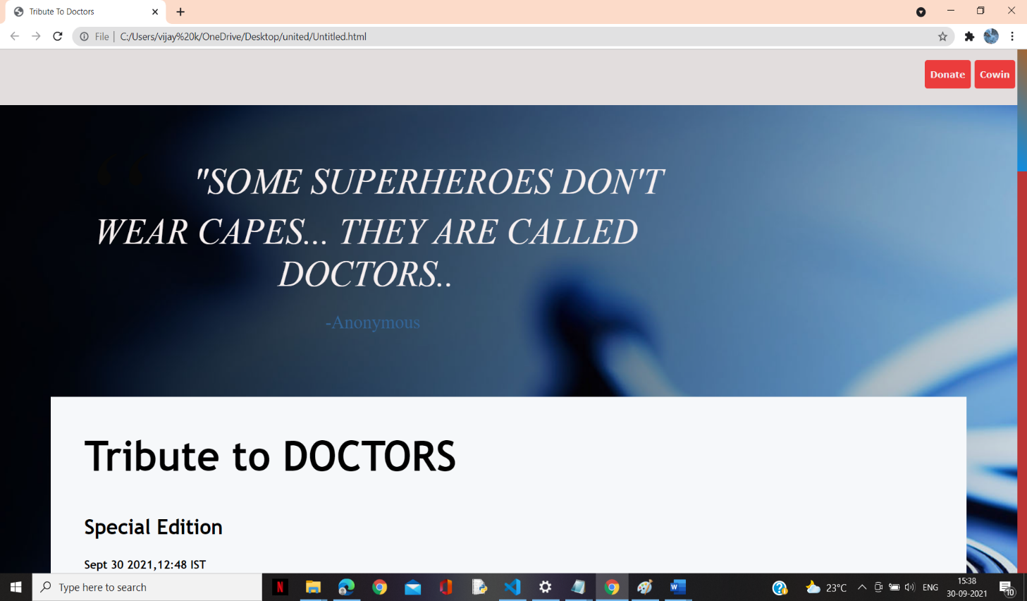

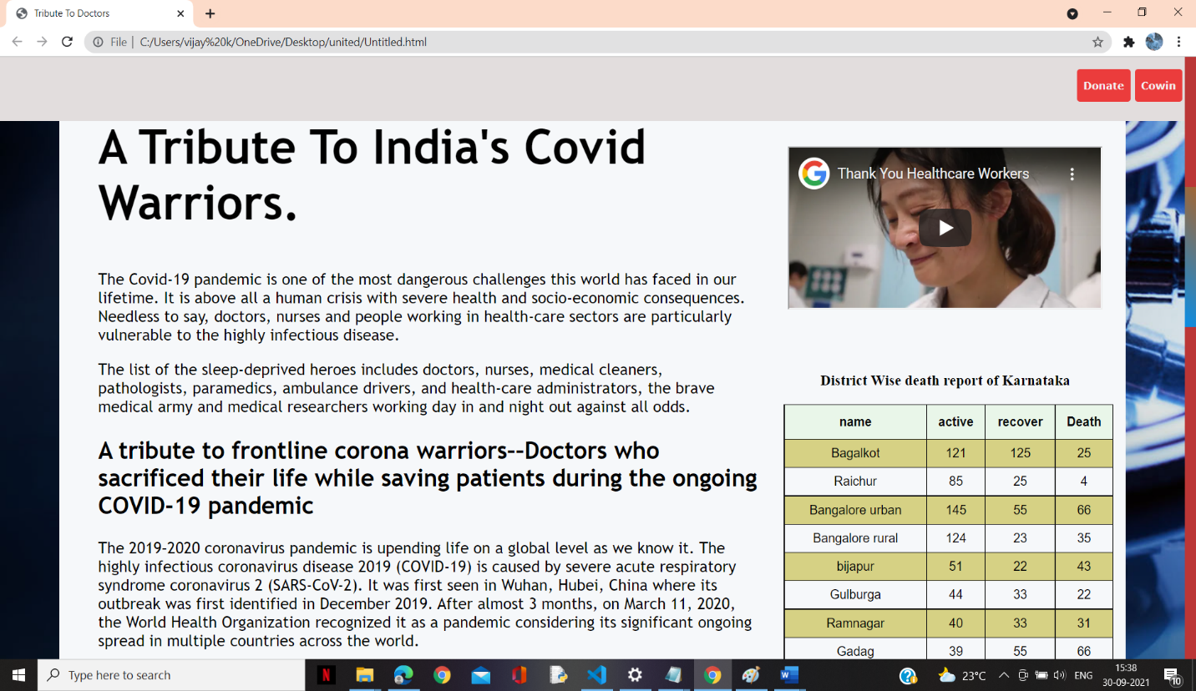

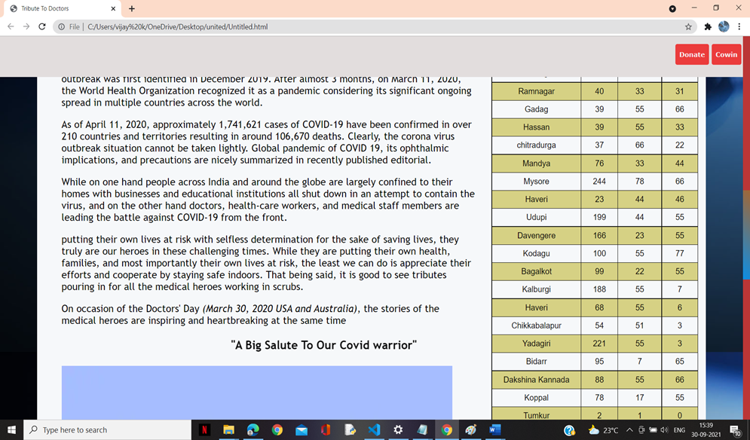

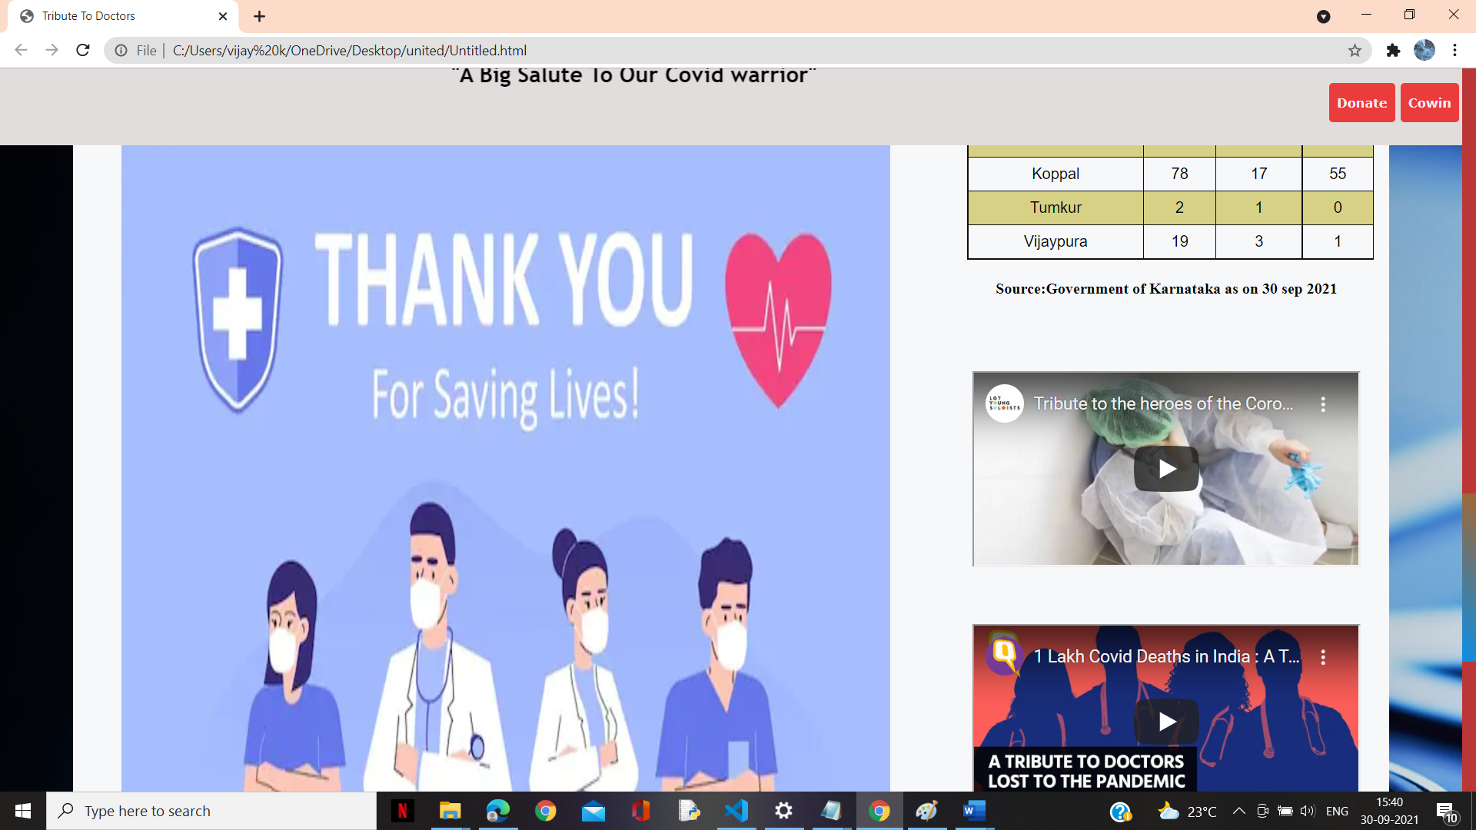

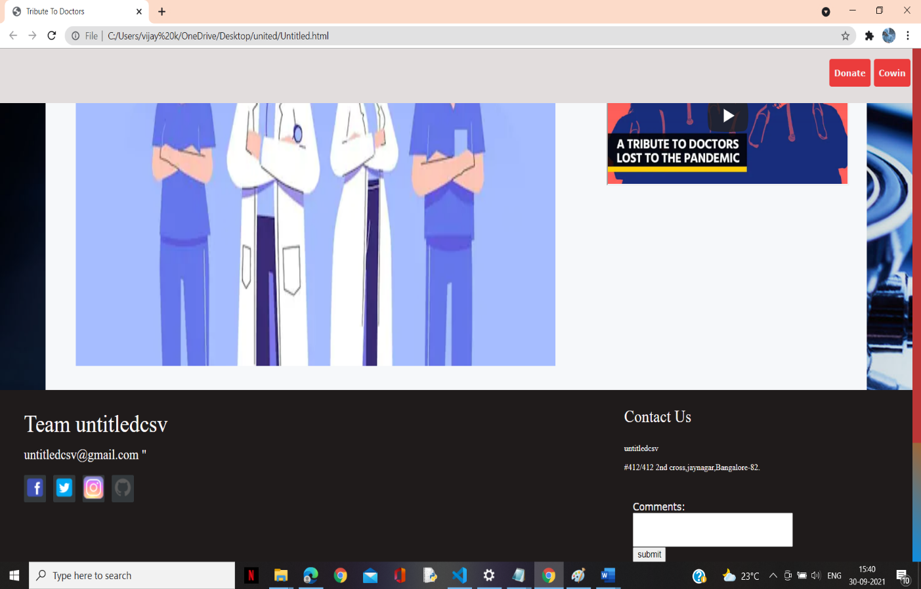

**BIBLIOGRAPHY**

* https://[www.w3schools.com](http://www.w3schools.com/)
* https://[www.geeksforgeeks.org](http://www.geeksforgeeks.org/)
* https://freefrontend.com

**About my TEAM**

My Team Name Is Untitledcsv .l have done this project individualy without help of anyone,I have done both HTML and CSS part of the project.

From this project I came to know about doctors and their sacrifice for people in covid situation.

Doctors ,nurses and many others in the healthcare sector have donned the role of a brave medical army fighting against coronavirus,standing strong with therrmometers,stethoscopes and ventilators as their weapons..

This is about my project and contribution towards the completion of this project.